6) Read Scripture – Meditate on short passages. Ask the Lord for direction and understanding. Pay specific attention to words that seem to jump out at you.

7) Pray to the Saints, ask their intercession Call on the saints to help you. Experience a particular closeness them. Read about their lives, and their sufferings.

8) Pray the Jesus Prayer – Repeat “Lord Jesus, have mercy on me, a sinner”.

9) Pray the Liturgy of the Hours or Psalms – There are many beautiful prayers by which you can speak to God.
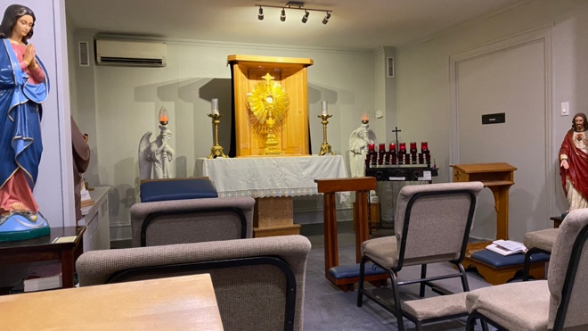

Our Perpetual Adoration Chapel is the golden crown and the spiritual engine room of our parish.

All who wish to adore Jesus in the Blessed Sacrament have access to this extraordinary opportunity for grace.
Answer, and satisfy the Lord’s thirst, and at the same time avail yourself of the abundant

graces, spending time in silence with the Lord, just keeping company with Him in the monstrance or enjoying your time with Him in the many ways to adore Him.
We encourage all parishioners and all adorers to sign up for at least one regular hour a week as a commitment, in a time slot not already assigned to another adorer. Coming at any time into the Real Presence of Jesus is highly encouraged. But to be committed for an hour, the same hour every week, is of such consolation to Our Lord and it opens the possibility of so many graces. Real Presence from God, real love from us!

For more information, and to sign-up for a hour, please contact:



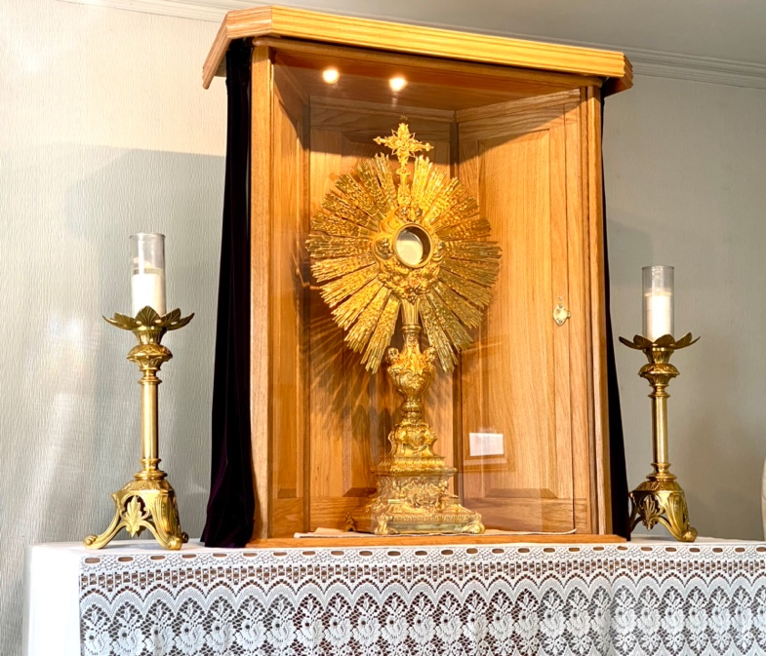



"….could you not watch with me one hour?”
(Matthew 26:40)

Jesus asked this of His closest companions in the Garden of Gethsemani, in one of His darkest moments of need, anticipating His imminent passion and death on the Cross. Today still, Jesus longs to share His love for us and receive our love in return. This desire is reflected in Mother Teresa’s motto for her community – “I Thirst”, and making a rule for her Sisters to adore the Lord in Adoration a minimum of one to two hours a day. A great many saints also had the daily habit of adoring Jesus in Eucharistic adoration for a holy hour each day, adoring Him, praising Him, and seeking His guidance on matters arising in their lives, and returning His love with their love.
He waits for us to visit Him and share our innermost thoughts and concerns with Him, to spend time with Him as a friend, and converse with Him in prayer.
We are called to pray as Catholics, to make reparation for our sins and the sins of the world, to praise and adore the Lord, to obtain graces to strengthen us in our daily battles in life. We can make prayers of petition for loved ones, for ourselves, and for our neighbours, and even our enemies - we are called to love all with our whole heart and soul, as ourselves. There is no more perfect way to be effective in prayer than to converse with Jesus physically present before us in the Holy Eucharist, which is the True Presence, the actual body and blood, soul and divinity of our Lord Jesus Christ. This True Presence is what we know from the Bible, the doctrines of our Holy Catholic Church, and attested to further by many Eucharistic miracles around the world, still happening today!


Things to do During Eucharistic Adoration

There are several kinds of prayer most appropriate in the presence of the Eucharist. These are prayers of adoration, praise, thanksgiving, repentance, and trusting intercession. Some suggestions are as follows:

1) Speak to Jesus - tell Him all your concerns, and listen for an answer. Pray the prayer given at Fatima. “My God, I believe, I adore, I trust and I love You; I beg pardon for those who do not believe, do not adore, and do not trust, and do not love You”.

2) Pray the Divine Mercy Chaplet – Pope John Paul II has given a special Apostolic Blessing for praying the Chaplet for the sick and the dying before the Blessed Sacrament, for mercy for the world.

3) Pray the Rosary - Pray to and with Mary, the Mother of God. Ask for her intercession to plead to her Son in the Eucharist for graces for yourself and the world.

4) “Be” with Jesus and just sit very quietly Pretend you are in the presence of the (Sun), and you feel the love of God (heat), enjoy His company, and listen to what He tells you.

5) Be repentant, ask for forgiveness, for yourself and for others – Name the people who you want to forgive. Pray for your families. Share your problems and your joys with the Lord.

