Please keep this posted on the bedside wall and give a copy to healthcare workers/caregivers.
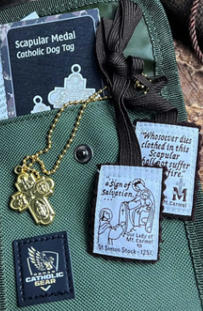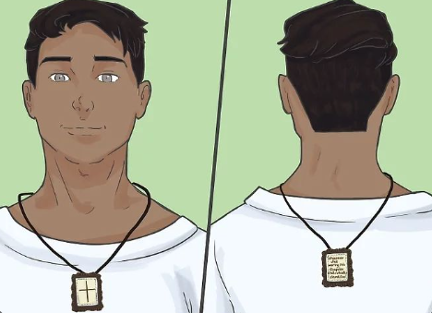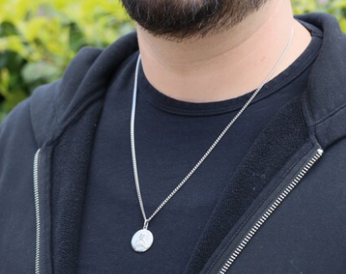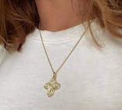
The cloth scapular or the scapular medal should be kept around the neck at all times.
(The medal can also be secured around the wrist or another body part).

To all healthcare workers/caregivers of _______________________.
It is the expressed/written desire of this patient and legal power of care/attorney involved to ensure the wearing of the cloth Brown Scapular or the Scapular Medal at all times during care, upon death and following death.
This patient ______________________ and family are grateful to you for honouring this very important religious request.

